

Course: Full Stack Development
Registration No: 211FA04163
Section: IV – E
Branch: CSE

Submitted To:
Raghav sir

- Database and Collection Setup
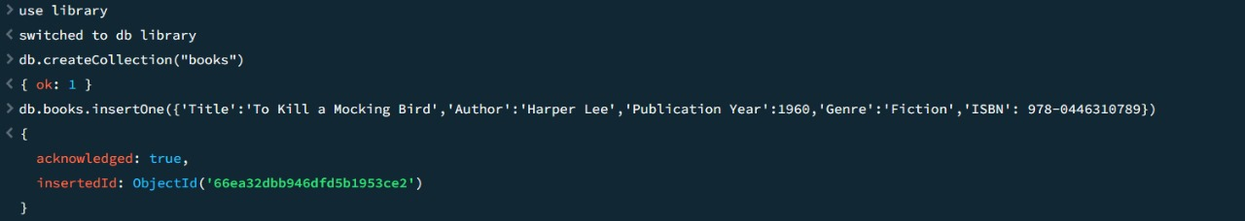

- Create Operation
In the above I have already inserted one book record into the books collection so now I am inserting only 4 records in this question.
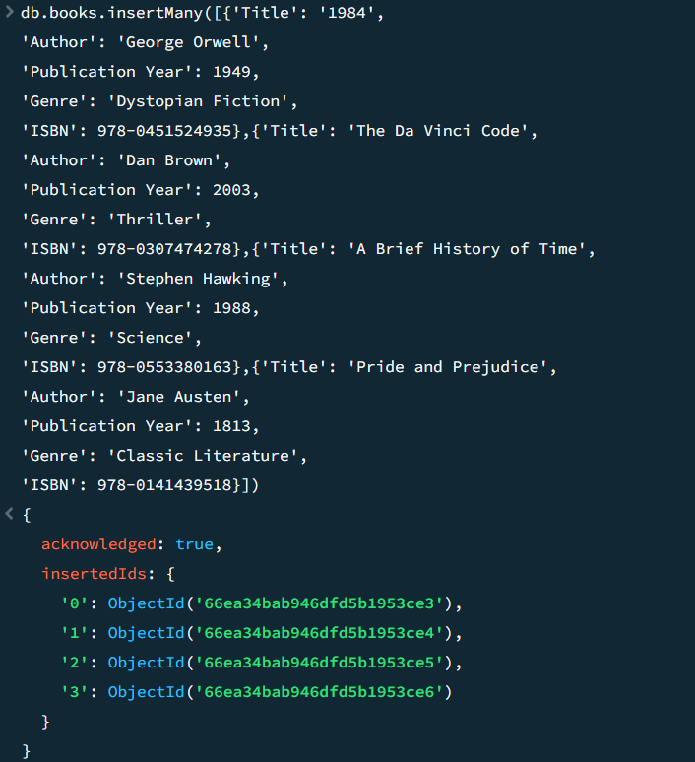

- Read Operation

- Update Operation

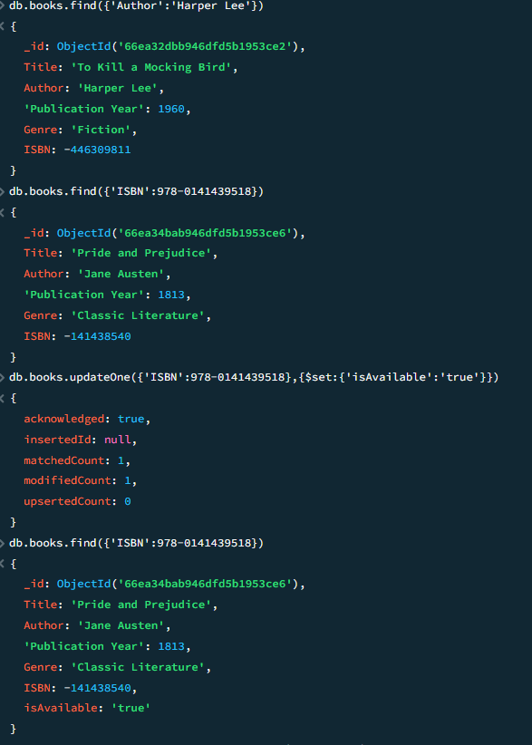
- Delete Operation
